DEPARTMENT OF INFORMATION TECHNOLOGY
PUDUCHERRY TECHNOLOGICAL UNIVERSITY
VIII SEMESTER

IT233 – PROJECT WORK

ZEROTH REVIEW 1.1 PROJECT REPORT 2025-26


A PREDICTIVE AND PRIORITY-DRIVEN RESPONSE SYSTEM FOR URBAN ROAD DAMAGE, WASTE OVERFLOW AND STREETLIGHT FAILURES USING ML TECHNIQUES
UNDER THE SUPERVISION OF
DR. P.MARAGATHAVALLI
PROFESSOR
DEPARTMENT OF INFORMATION TECHNOLOGY
PUDUCHERRY TECHNOLOGICAL UNIVERSITY

SUBMITTED BY
SELVAM MARILYN- 2201112040
DHINESH S - 2201212002
MUTHUKUMARAN A S - 2201112030

Approved Title - Signature of the Guide

REVIEW QUERIES
Question 1: What are the specific areas/domains of the complaint system?
Question 2: How will the project title be refined to reflect this narrowed scope?
Question 3: What are the specific inputs and outputs of the system?
Question 4: What is the novelty of the proposed system compared to existing solutions?
Question 5: What real-time (R-T) datasets or URLs will be used for the project?

JUSTIFICATION 1: DOMAIN OF THE COMPLAINT SYSTEM
QUESTION: What are the specific areas/domains of the complaint system?
ANSWER:
The scope has been narrowed down to infrastructure and sanitation which includes Road Damage, Garbage, and Streetlights ensures the Machine Learning models can be trained on high-quality, specific datasets.
Reference: [2] “CivicFix: Smart complaint routing for urban solutions,” IJARCCE, Dec. 2025.
Page: 145
"Streamlines workflows by automatically routing reports to departments via CNN classification".

JUSTIFICATION 2: REFINED PROJECT TITLE
QUESTION: How will the project title be refined to reflect this narrowed scope?
ANSWER:
The original broad title is being replaced with "Predictive and Priority-Driven Management System for Urban Road Damage, Waste Overflow and Streetlight Failures using ML Techniques" to accurately represent the refined technical scope.

Reference: [1] Smart complaint system using generative AI, Zhuzao/Foundry, Aug. 2025.
Page: 241
" This project proposes a Predictive Urban Issue Management and Response System—a unified digital framework that transforms citizen-driven data into strategic municipal intelligence.”

JUSTIFICATION 3: INPUTS AND OUTPUTS OF THE SYSTEM
QUESTION: What are the specific inputs and outputs of the system?
ANSWER:
The system utilizes geo-tagged multimedia evidence and citizen text as primary inputs to ensure high-quality data acquisition. These are processed into prioritized work orders and predictive heatmaps to guide efficient municipal resource allocation.
Reference: [3] Smart civic complaint analyzer using natural language processing, IJIRT, Aug. 2025.
Page: 5408
" This project proposes a Predictive Urban Issue Management and Response System—a unified digital framework that transforms citizen-driven data into strategic municipal intelligence.”

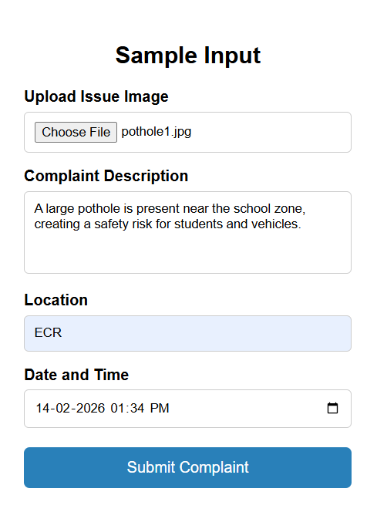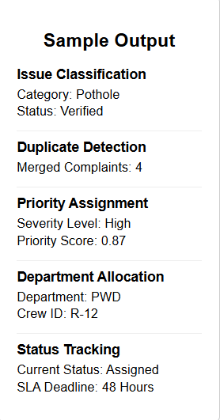

JUSTIFICATION 4: THE NOVELTY OF THE PROPOSED SYSTEM
QUESTION: What is the novelty of the proposed system compared to existing solutions?
ANSWER:
Unlike traditional reactive databases, this system uses predictive intelligence to visualize future hotspots and allocate resources mathematically. It shifts urban governance from simple monitoring to a proactive model that resolves issues before they escalate.
Reference: [4] Smart infrastructure management framework with computer vision and predictive analytics, IJSRET, Mar. 2025.
Page: 1509
"Enables proactive maintenance by monitoring the physical condition of assets and predicting future failures".

JUSTIFICATION 5: R-T datasets or URLs
QUESTION: What real-time (R-T) datasets or URLs will be used for the project?
ANSWER:
The project utilizes the Potholes and Road Damage dataset and the Civic Issue Detection dataset from Kaggle and GitHub. These provide annotated images and text necessary to train the CNN and NLP models for real-world urban anomalies.
Referred Dataset URLs:
- https://www.kaggle.com/datasets/trolololo888/potholes-and-road-damage-with-annotations
- https://www.kaggle.com/datasets/abhyudayapokhrel/civic-issue-dataset
- https://www.kaggle.com/datasets/bhanu77/garbage-overflow
- https://www.kaggle.com/datasets/abhyudayapokhrel/civic-issue-dataset
5. https://github.com/Sshanu/civic_issue_dataset civic issue reporting

Reference: [8] AI in smart cities: Accelerating urban sustainability, GJETA, Sep. 2025.
Page: 51
"Creating intelligent systems capable of processing diverse datasets to improve city-wide resource efficiency".

TABLE OF CONTENTS

SI. NO. | TOPIC | PAGE NO.
1 | ABSTRACT | 1
2 | INTRODUCTION | 1
3 | PROJECT OBJECTIVES | 3
4 | LITERATURE SURVEY | 3
5 | INFERENCE FROM LITERATURE SURVEY | 5
6 | PROPOSED WORK | 5
7 | DESIGN DIAGRAM | 6
8 | INPUT AND OUTPUT SPECIFICATIONS | 7
9 | PROJECT MODULES | 8
10 | HARDWARE AND SOFTWARE REQUIREMENTS | 9
11 | CONCLUSION | 10
12 | TIME-LINE CHART | 10
13 | REFERENCES | 11

ABSTRACT

Traditional urban management systems often operate through isolated, reactive, and passive channels that struggle to address complex, multi-domain civic issues in real time. Although several digital reporting platforms exist for citizen complaints, they typically lack intelligent mechanisms to validate reported data, identify patterns, or prioritize issues based on urgency, impact, and available municipal resources. As a result, many urban problems remain unresolved or are addressed inefficiently, leading to delayed responses and reduced public trust.

This project proposes a PREDICTIVE AND PRIORITY-DRIVEN RESPONSE SYSTEM FOR URBAN ROAD DAMAGE, WASTE OVERFLOW AND STREETLIGHT FAILURES USING ML TECHNIQUES (PPRS-RD-WO-SF-MLT), a unified digital framework aimed at transforming citizen-generated data into actionable municipal intelligence. The system integrates machine learning techniques for automated issue classification, trend prediction, and anomaly detection, enabling authorities to proactively identify recurring urban issues before they escalate. Mathematical prioritization models are employed to rank reported problems based on severity, location, frequency, and resource constraints, ensuring optimal workforce allocation and faster resolution.

By shifting from traditional complaint logging to a predictive and data-driven approach, the proposed system enhances coordination between citizens and municipal authorities. Ultimately, PUIM-RS-MLT promotes timely decision-making, efficient resource utilization, and sustainable urban governance, contributing to the development of smarter and more responsive cities.

INTRODUCTION

Urban centers across the globe are increasingly challenged by rapid population growth, unplanned expansion, and rising demands on public infrastructure and essential services. These pressures frequently result in infrastructure breakdowns, environmental degradation, public safety concerns. Traditionally, urban issue management has relied on manual, fragmented, and siloed processes where citizens report problems through phone calls, emails, or physical visits to municipal offices. Authorities typically respond only after an issue becomes severe, following a reactive maintenance model that is inefficient, resource-intensive, and lacking in accountability and transparency.

Although several digital platforms have been introduced to streamline complaint registration, most function merely as static databases. They fail to assess issue severity, verify data authenticity, identify recurring patterns, or support optimal deployment of limited municipal resources. Consequently, decision-making remains largely subjective and delayed.

The proposed system acts as a centralized urban intelligence platform covering urban road damage, waste overflow and streetlight failures. By integrating real-time citizen reports with machine learning-based classification, predictive analytics, and mathematical prioritization models, the system enables authorities to visualize issue hotspots, forecast potential failures, and allocate resources efficiently. This transition from passive monitoring to predictive urban management ensures timely intervention, improved service delivery, and the development of smarter, more sustainable cities.

PROJECT OBJECTIVES

The primary goal of this project is to create an intelligent, end-to-end framework for urban governance. The specific objectives are:

Objective 1: Unified Multi-Domain Reporting and Automated Classification: To develop a system that enables citizens to report multi-domain urban issues and automatically classifies incoming reports into predefined categories for efficient routing to the appropriate municipal departments.

Objective 2: Dynamic Priority Scheduling: To design a dynamic scoring engine that ranks complaints based on public safety, environmental impact, and urgency.

Objective 3: Proactive Trend Analysis: To identify historical patterns and generate predictive heatmaps of urban issue hotspots for better administrative planning.

LITERATURE SURVEY

The development of the Predictive And Priority-Driven Response System For Urban Road Damage, Waste Overflow And Streetlight Failures Using Ml Techniques (PPRS-RD-WO-SF-MLT) is grounded in an extensive review of existing research in the domains of smart cities, urban governance, and artificial intelligence. Several studies have focused on improving citizen–government interaction through digital platforms. A Smart Complaint System using Generative AI leveraged BLIP-2 and Gemini AI to convert citizen-submitted images into automated textual descriptions, thereby reducing manual interpretation efforts and improving reporting efficiency [1]. However, such systems primarily emphasize data conversion rather than decision-making or prediction.
Another significant contribution, CivicFix, utilized Convolutional Neural Networks (CNNs) to classify and route complaints to appropriate municipal departments [2]. While this approach improves workflow automation, it remains largely reactive and does not prioritize issues based on urgency or resource constraints. Similarly, text-based complaint analysis systems such as the Smart Civic Complaint Analyzer employed TF-IDF and Naive Bayes classifiers to extract key information like urgency and location from reports [3]. These methods, though effective for textual data, lack multimodal validation and fail to correlate text with visual evidence.
Spatial intelligence has also been explored through Predictive Visualization of Community Municipal Challenges, using Random Forest Regression and K-Means Clustering to identify geographical hotspots and recurring problem zones [7]. While valuable for visualization, these systems do not integrate predictive response planning. Further research in AI-driven Smart Infrastructure Management applied CNN and LSTM models to monitor infrastructure health and enable proactive maintenance [4]. Additionally, governance-focused frameworks introduced escalation mechanisms, Aadhaar-based verification, and SMS notifications to enhance accountability and transparency [5].

To address data redundancy in large-scale reporting, studies in Duplicate Report Detection in Urban Crowdsensing have focused on identifying overlapping submissions using spatial and temporal analysis [6] to optimize administrative workload. Beyond simple categorization, the integration of AI in Smart Cities[8] has been identified as a critical driver for accelerating urban sustainability by creating intelligent systems capable of processing diverse datasets to improve city-wide resource efficiency. Furthermore, recent research in Machine Learning-based priority assignment has introduced weighted scoring functions [9] to rank urban complaints based on public safety and environmental impact, ensuring that critical infrastructure failures are addressed before minor aesthetic issues.

INFERENCE FROM LITERATURE SURVEY
Existing system indicate a necessary shift toward proactive governance by using time-series models like LSTM to forecast issue hotspots. To achieve effective monitoring, there is a clear necessity for Multimodal AI, which converges Computer Vision for detecting physical anomalies like potholes and cracks with Natural Language Processing (NLP) for the categorization of human-reported text.
Operational efficiency can only be achieved through Mathematical Optimization. Literature proves that uncoordinated crowdsensing leads to significant economic waste; therefore, Linear Programming is essential to eliminate duplicate reports and prioritize high-severity tasks effectively. Furthermore, to mitigate citizen disengagement, the system must incorporate Automated Accountability Frameworks, such as escalation protocols that forward unresolved issues to higher authorities after a set timeframe. High-precision resolution also relies on Geospatial and Mobile Integration, utilizing automated geotagging to remove manual errors and Progressive Web Apps (PWA) for real-time, cross-platform accessibility.
The comprehensive analysis of existing research underscores a critical necessity for urban management systems to transition from traditional reactive models to data-driven proactive governance. While current frameworks primarily focus on simple complaint logging, the literature suggests that sustainable city management requires the integration of time-series models, such as Long Short-Term Memory (LSTM) or ARIMA, to accurately forecast regional issue hotspots and seasonal trends before they escalate into infrastructure failures.
To achieve high-fidelity monitoring, there is an evident requirement for Multimodal AI Integration. Effective urban oversight cannot rely on a single data stream; instead, it must converge Computer Vision for identifying physical anomalies—such as potholes, structural cracks, or illegal dumping—with Natural Language Processing (NLP) to analyze the sentiment and urgency within citizen-reported text. This multimodal approach ensures that reports are cross-validated, preventing the administrative burden of unverified or low-quality data.
Operational efficiency and financial sustainability are identified as major hurdles that can only be resolved through Mathematical Optimization. As demonstrated in the literature, uncoordinated crowdsensing and redundant reporting lead to significant economic waste and fragmented municipal responses. Consequently, the implementation of Linear Programming (LP) models is essential to mathematically eliminate duplicate reports and prioritize high-severity tasks based on available workforce and budget constraints.
Finally, the success of modern civic engagement relies heavily on Geospatial and Mobile Integration. High-precision resolution is dependent on automated geotagging to remove manual location errors and the deployment of Progressive Web Apps (PWA) to ensure real-time, cross-platform accessibility for all citizens. By synthesizing these technological pillars—predictive analytics, multimodal validation, mathematical optimization, and transparent accountability—the proposed PPRS-RD-WO-SF-MLT system provides a robust solution for the sustainable smart cities of the future.

PROPOSED WORK: PPRS-RD-WO-SF-MLT

The proposed "Predictive Urban Issue Management and Response System using Machine Learning Techniques" (PPRS-RD-WO-SF-MLT) introduces an AI-driven, integrated platform designed to bridge the gap between citizen reporting and municipal response through predictive analytics and mathematical optimization. This project facilitates Intelligent Acquisition by utilizing a responsive Web/PWA interface that leverages Camera APIs and GPS auto-capture for high-quality, geo-tagged reporting. For validation, the system employs Multimodal AI techniques, concurrently using CNNs (ResNet/MobileNet) for image recognition and NLP (SVM/Naive Bayes) for textual classification and sentiment-based severity estimation.
To maintain data integrity, the framework implements Perceptual Hashing and DBSCAN clustering to eliminate duplicate reports and filter spam, effectively merging redundant entries into "priority upvotes". The project further integrates Predictive Analytics using Prophet/LSTM models to analyze historical trends and generate predictive heatmaps for proactive administrative planning. Finally, the system ensures Optimal Resource Allocation through a Linear Programming (LP) model that minimizes response time and cost by matching critical tasks with the nearest qualified maintenance crews.

HIGH LEVEL ARCHITECTURAL DIAGRAM

The architecture follows a structured flow from citizens and officials through a web/mobile interface to a REST API layer. The backend server manages issue processing, duplicate checks, and dynamic priority scoring. It integrates with an AI Predictive Analytics module and ML models for clustering and regression. All data is managed within a centralized database.

- User Interaction Layer: Both citizens and government officials interact with the system through a Web/Mobile Application. This layer contains the Issue Reporting Form, Map View and Heatmap, Dashboards, and Status Tracking components.
- REST API Layer: This communication bridge handles Request Handling, Authentication, and API Communication between the frontend and the backend.
- Backend Application Server: The core intelligence of the system resides here, featuring an Issue Management Module for report processing and duplicate checks, and a Workflow and Assignment Module for department routing and status updates.
- Intelligent Modules: The backend is supported by a Dynamic Priority Scoring Engine, an AI Predictive Analytics Module for trend prediction and severity assessment, and ML Models utilizing clustering and regression techniques.

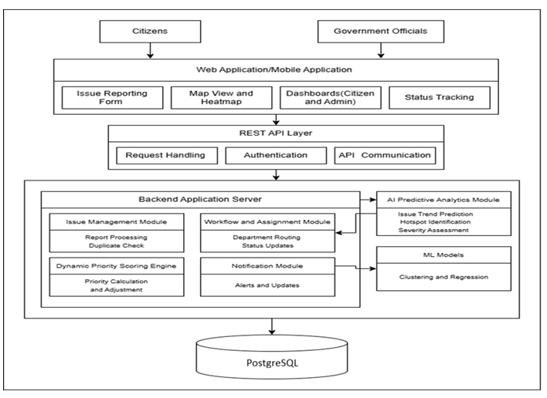
FIG 1: High Level Architecture of PUIM-RS-MLT

SAMPLE INPUT AND OUTPUT
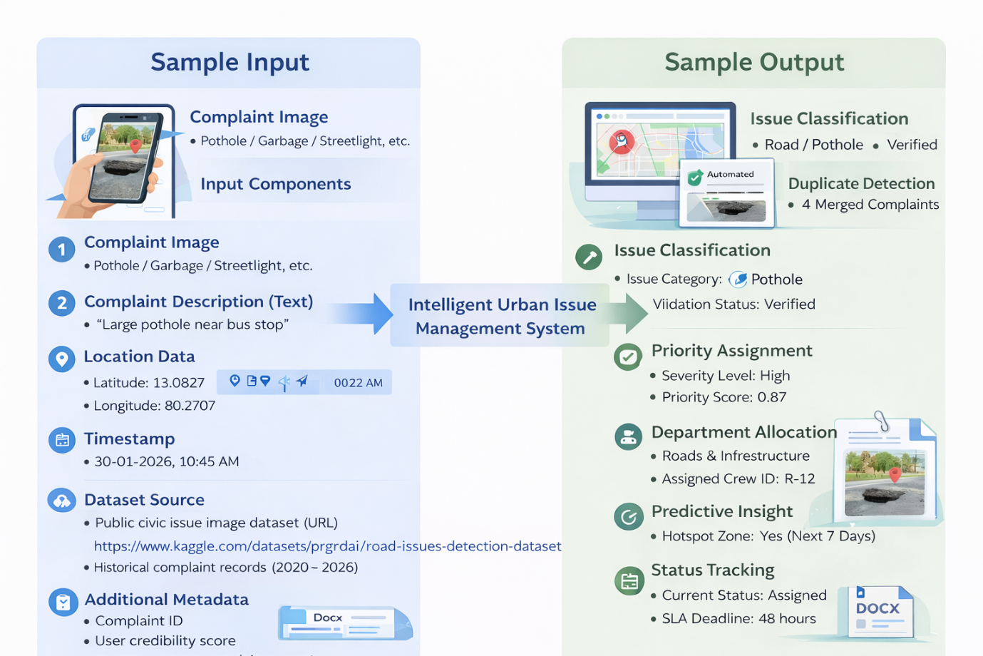

PROJECT MODULES

The system is decomposed into four primary modules, further broken down into specific tasks and activities to ensure a systematic development process.

Module 1: Citizen Interface & Data Acquisition
Purpose: To capture reliable, geo-tagged, high-quality urban issue data from citizens.
- Task 1.1: Smart Issue Reporting Interface: Designing a responsive Web and Mobile PWA with one-tap reporting. This involves integrating Camera APIs with image compression and implementing GPS auto-capture with reverse geocoding for human-readable addresses.

- Task 1.2: Issue Tracking & Feedback: Developing a status lifecycle (Reported → Verified → Assigned → In-Progress → Resolved). It includes implementing real-time push, SMS, and email notifications, along with star-rating feedback systems.

- Task 1.3: User Authentication & Trust Scoring: Implementing secure JWT-based authentication with OTP. This task also involves designing a User Credibility Score based on report validity and creating a personal contribution dashboard for transparency.

Module 2: Automated Issue Validation & Classification
Purpose: To automatically verify, classify, and clean incoming data using Machine Learning.
- Task 2.1: Image-Based Issue Classification: Preprocessing and augmenting datasets for potholes, garbage, and leaks. This includes training a CNN model for multi-class recognition and exposing a REST API for confidence scoring.

- Task 2.2: Text-Based NLP Classification: Implementing tokenization, lemmatization, and stop-word removal. Models like SVM or Naive Bayes are trained to classify descriptions into departments and perform sentiment analysis to estimate perceived severity.

- Task 2.3: Duplicate Detection & Spam Filtering: Computing perceptual image hashes to detect similar reports. It applies DBSCAN clustering on geo-coordinates to group nearby issues and merge duplicates as "priority upvotes".

Module 3: Priority Scoring & Predictive Intelligence
Purpose: To rank issues dynamically and forecast future problem hotspots.
- Task 3.1: Dynamic Priority Scoring Engine: Implementing a weighted formula combining severity, volume, and age. It integrates external data (e.g., weather) for adaptive prioritization and defines rule-based thresholds for automatic critical flagging.

- Task 3.2: Trend Analysis & Hotspot Prediction: Aggregating historical data by time and location to train Prophet or LSTM models for short-term (7–30 day) forecasting. This outputs predictive heatmaps for administrative planning.

- Task 3.3: Emergency & Anomaly Detection: Detecting spikes in reports using statistical thresholds. This triggers emergency workflows for disasters (like floods) and sends automated alerts to senior officials.

Module 4: Resource Optimization & Administrative Control
Purpose: Optimize workforce deployment, ensure SLA compliance, enable administrative decision-making, and support adaptive system intelligence.

Task 4.1: Resource Allocation: Assign the most suitable maintenance crew to each issue based on priority, availability, skill set, and location.

Task 4.2: SLA Monitoring & Escalation: Track resolution deadlines and automatically trigger alerts or escalation for delayed issues.

Task 4.3: Administrative Decision Support: Provide a centralized dashboard to monitor issue status, resource performance, and support governance decisions.

SIMULATION/IMPLEMENTATION ENVIRONMENT
The implementation of the PPRS-RD-WO-SF-MLT system is designed to occur in a hybrid development environment that bridges mobile client-side acquisition with high-performance server-side processing. The primary simulation environment for the Machine Learning models will be Python-based, utilizing specialized libraries for training the CNN (MobileNet/ResNet) for image recognition and NLP engines (SVM/Naive Bayes) for textual classification. For the optimization component, the Linear Programming (LP) model will be simulated using the PuLP solver to determine the most efficient crew-to-task assignments.
The user-facing application will be developed as a Progressive Web App (PWA) using the Flutter framework, allowing for cross-platform simulation on both web browsers and mobile devices. This environment supports the simulation of real-time GPS auto-capture and Camera API interactions essential for geo-tagged reporting. Integration testing will be conducted through a REST API layer, ensuring seamless synchronization between the citizen-reported data, the AI processing modules, and the central administrative dashboard

HARDWARE & SOFTWARE REQUIREMENTS

SOFTWARE REQUIREMENTS

Programming Language: Python 3.13
Mobile Application Framework: Flutter SDK
Backend Framework: Flask or FastAPI (REST API development)
Machine Learning Libraries: TensorFlow / Keras, Scikit-learn
Optimization Solver: PuLP (for priority scoring and resource optimization)
Database: PostgreSQL (for issue storage and analytics)
Frontend (Optional Admin Dashboard): Flutter Web or any web-based UI framework
Development Tools: VS Code, Git

HARDWARE REQUIREMENTS

Processor: Multi-core processor (Intel Core i5 or equivalent or higher)

RAM: Minimum 8 GB (16 GB recommended for machine learning processing)

Storage: Minimum 50 GB SSD for datasets, logs, and model storage

Network: Stable internet connection for real-time data submission and system access

WORK PLAN

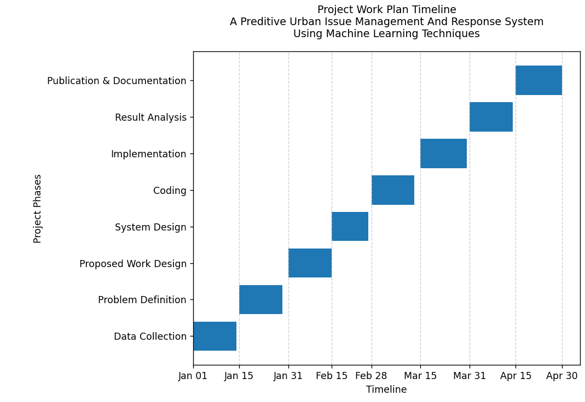

CONCLUSION

The Predictive Urban Issue Management and Response System using Machine Learning Techniques (PPRS-RD-WO-SF-MLT) transforms traditional urban governance from a reactive approach into a proactive, data-driven framework. By combining AI-based issue classification with mathematical prioritization, the system ensures that citizen-reported problems are accurately validated, effectively prioritized, and resolved in a timely manner. This approach significantly reduces manual administrative effort while enabling optimal use of limited municipal resources. Through centralized reporting, intelligent analysis, and transparent issue tracking, the system improves coordination between citizens and authorities. Overall, PPRS-RD-WO-SF-MLT provides a reliable and scalable foundation for efficient urban management and contributes to the development of smarter, more responsive cities.

REFERENCES

[1] M. Manu and A. G. L., “Smart complaint system using generative AI,” Zhuzao/Foundry, Vol. 28, No. 8, pp. 241–250, Aug. 2025.
[2] R. Kumar, B. N. Kumar, S. Thanusha, et al., “CivicFix: Smart complaint routing for urban solutions,” Int. J. Adv. Res. Comput. Commun. Eng., Vol. 14, No. 12, pp. 145–151, Dec. 2025.
[3] C. Ashwitha and K. Vani, “Smart civic complaint analyzer using natural language processing,” Int. J. Innov. Res. Technol., Vol. 12, No. 6, pp. 5408–5415, Nov. 2025.
[4] S. Naphade et al., “Smart infrastructure management framework with computer vision and predictive analytics,” Int. J. Sci. Res. Eng. Trends, Vol. 11, No. 2, pp. 1509–1512, Mar. 2025.
[5] G. Shanmugam and A. Dharani, “Revolutionizing civic complaints with intelligent complaint management system,” Int. Res. J. Mod. Eng. Technol. Sci., Vol. 7, No. 5, pp. 7518–7521, May 2025.
[6] J. Zhang and D. Wang, “Duplicate report detection in urban crowdsensing applications,” in Proc. IEEE Int. Conf. Smart Cities, 2015, pp. 1–6.
[7] S. Tharun and G. P. Babu, “Predictive visualization of community municipal challenges,” Int. J. Res. Appl. Sci. Eng. Technol., Vol. 13, No. 9, pp. 65–74, Sep. 2025.
[8] J. C. Nwaigbo et al., “AI in smart cities: Accelerating urban sustainability,” Global J. Eng. Technol. Adv., Vol. 24, No. 3, pp. 51–73, Sep. 2025.
[9] A. Singh and R. Patel, “Machine learning-based priority assignment for smart city complaint management,” Int. J. Smart Comput., Vol. 10, No. 4, pp. 210–218, Apr. 2025.

